SOLUTIONS

Module: | 3D Graphics Programming Tools
Module Code | EBU7405 | Paper | A
Time allowed | 2hrs | Filename | Solutions_2021_EBU7405_A
Rubric | Answer ALL FOUR questions
Examiners | Dr Marie-Luce Bourguet | Dr Pengwei Hao

Question 1
a) What is the general format of the glVertex function? Explain why it needs several versions and provide examples.
[5 marks]

Solution: The general format of the function is: glVertex for the function name (1 mark), then a number that indicates the number of arguments (1 mark), then a letter that indicates the type of the arguments (1 mark). Examples: glVertex3f, glVertex2d (1 mark). The several versions are needed because OpenGL is not object oriented and so does not allow function overloading (1 mark).

b) Write an OpenGL orthographic projection statement which guarantees that a sphere of radius 5 can be entirely contained in the viewing volume without distortion.
[5 marks]

Solution: for example, glOrtho (-20.0, 20.0, -20.0, 20.0, -20.0, 20.0); (2 marks for the name of the function; 1 mark for each pair of valid parameters, up to 3 marks).

c) This question is about the OpenGL camera.
[6 marks]
- What are the characteristics of the default OpenGL camera?
(3 marks)
Solution: Located at the origin of the coordinate system and aligned with the z axis (1 mark); default viewing volume is a cube of size 2 (1 mark); the default projection is orthographic (1 mark).
ii) Which OpenGL function allows you to set the location and orientation of the camera? How does it work?
(3 marks)
Solution: Using the gluLookAt function (1 mark); the 3 “eye” parameters set the position (1 mark), and the 3 “at” parameters set the orientation (1 mark).

d) Consider the code shown in Code Box 1 on the next page.
[9 marks]
- Which two statements can be removed from the code without modifying its output?
(2 marks)
Solution: glClearColor (0.0, 0.0, 0.0, 1.0); (1 mark)
glShadeModel (GL_SMOOTH); (1 mark)

- Explain the purpose of the following statement:
glGetIntegerv (GL_VIEWPORT, viewport);
(4 marks)
Solution: This statement retrieves the Viewport values (X, Y, Width, Height) (1 mark) and places them in the viewport variable (1 mark). The mouse position in the screen window is usually measured with the origin at the top-left corner (1 mark) and so it must be inverted by the window’s Height (1 mark).

- Modify the code so a click on the right button of the mouse terminates the program.
(3 marks)
Solution: the following lines of code must be added in the mymouse callback:

If (btn==GLUT_RIGHT_BUTTON && state==GLUT_DOWN) (2 marks)
exit (0); (1 mark)

#include <GL/glut.h>

GLdouble W = 640.0;
GLdouble H = 480.0;
GLint size = 30;

void myInit(void) {
glClearColor (0.0, 0.0, 0.0, 1.0);
glMatrixMode (GL_PROJECTION);
glLoadIdentity();
gluOrtho2D (0, W, 0, H);
}

void mydisplay(){
}

void drawSquare(int x, int y)
{
GLint viewport[4];
glGetIntegerv (GL_VIEWPORT, viewport);
y = viewport[3] - y;
glShadeModel(GL_SMOOTH);
glBegin(GL_POLYGON);
glVertex2i(x+size, y+size);
glVertex2i(x-size, y+size);
glVertex2i(x-size, y-size);
glVertex2i(x+size, y-size);
glEnd();
glFlush();
}

void mymouse(int btn, int state, int x, int y)
{
if(btn==GLUT_LEFT_BUTTON && state==GLUT_DOWN)
drawSquare(x, y);
}

int main(int argc, char** argv){
glutInit(&argc, argv);
glutInitWindowSize(W, H);
glutCreateWindow("simple");
glutDisplayFunc(mydisplay);
glutMouseFunc(mymouse);
myInit();
glutMainLoop();
}

Question 2
a) What is Euler’s formula for a convex polyhedron? Explain your variables.
[4 marks]
Solution:
V – E + F = 2
V: # of vertices
E: # of edges
F: # of faces
(1 mark for each point, total 4 marks)

b) This question is about geometric transformations.
[11 marks]
- Consider Model A and Model B in Figure 1. Give a chain of the basic transformation matrices for translation, scaling and rotation which, when post-multiplied by the homogeneous coordinates of the vertices of Model A, will transform the vertices of Model A into their corresponding vertices of Model B, such that the vertex at 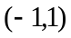 of Model A is transformed to the vertex at 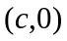 of Model B.
(7 marks)
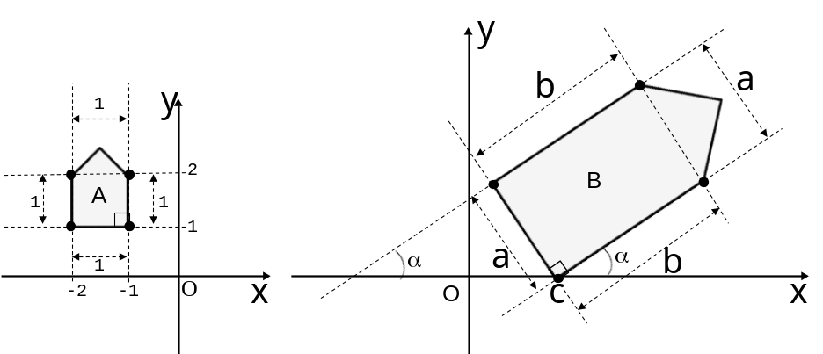
(Model A) (Model B)
Figure 1.
Solution:
The matrices can be 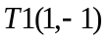 for translation, 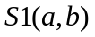 for scaling, 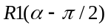 for rotation , and 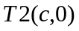 for translation: (2 marks)
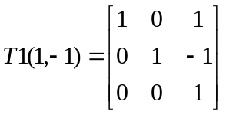 (1 mark)
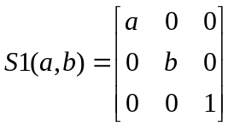 (1 mark)
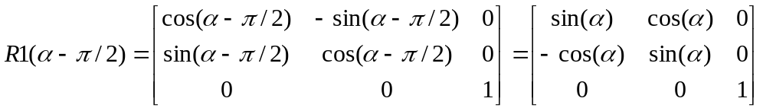 (2 marks)
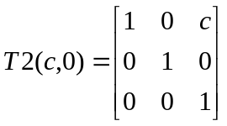 (1 mark)
[Total 7 marks]

ii) Compute the composite 2D transformation matrix for the transformations found in question i) above.
(4 marks)
Solution:
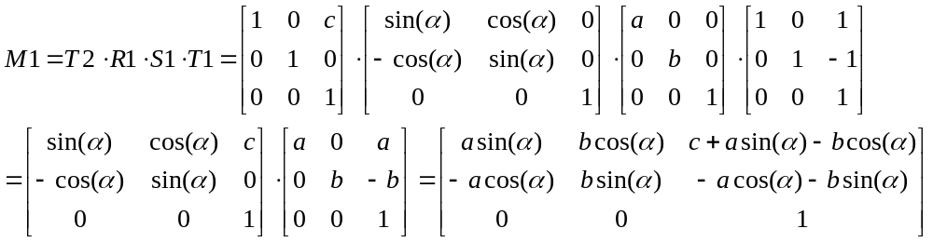
(1 mark for each step, total 4 marks)

c) Starting from the object model shown on Figure 2 a), find the single modelling transformation that can create the object instance shown in Figure 2 b). Give the corresponding OpenGL command with appropriate arguments. Justify your choice of transformation and arguments.
[6 marks]

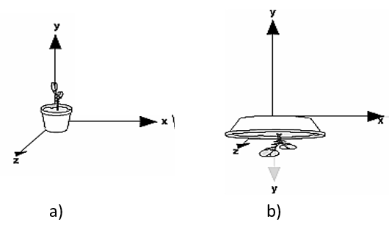
Figure 2.

Solution: this transformation is a non-uniform scaling transformation (1 mark) that includes a mirror about X axis (1 mark).
OpenGL function: glScalef(3.0, -1.0, 1.0). 1 mark for the function name, 1 mark per valid argument, which can be slightly different from the ones shown here (up to 3 marks).

d) What are the 4 printing primary colours used in printing? Give the relations between the 4 printing primary colours and the 3 additive primary colours.
[4 marks]
Solution:
The 4 printing primary colours are Cyan, Magenta, Yellow & Black (CMYK). (2 marks)
The relations are
K = min(C,M,Y); [C,M,Y] = [C,M,Y] - K. (2 marks)
(total 4 marks)

Question 3
a) This question is about lighting calculations in OpenGL. Describe the appearance (colour and shininess) of an object illuminated under the conditions declared in Code box 2.
[6 marks]

float light_ambient[] = {0.5, 0.5, 0.5, 1.0};
float light_diffuse[] = {1.0, 1.0, 1.0, 1.0};
float light_specular[] = {1.0, 1.0, 1.0, 1.0};
float material_ambient[] = {0.2, 0.3, 0.2, 1.0};
float material_diffuse[] = {0.0, 0.4, 0.4, 1.0};
float material_specular[] = {1.0, 1.0, 1.0, 1.0};
float shininess = 100.0;

Code box 2

Solution: The ambient light component is grey (1 mark), which the object will reflect according to its material_ambient components: (0.5*0.2, 0.5*0.3, 0.5*0.2) = (0.1, 0.15, 0.1) (1 mark). The ambient reflection is a very dark and unsaturated green. (1 mark)
Diffuse calculations: (1.0 * 0.0, 1.0 * 0.4, 1.0 * 0.4) = (0.0, 0.4, 0.4), which is a fully saturated but not very bright cyan (1 mark).
Specular component: the shininess is set to 100, so there will be a very small highlight, which will be white (1 mark).
Overall, the faces directly illuminated by the light source will appear shiny and the colour will be: (0.1+0.0, 0.15+0.4, 0.1+0.4) = (0.1, 0.45, 0.5) which is a kind of dark cyan (1 mark).

b) This question is about WebGL.
[9 marks]
- What are the roles of the vertex shader and of the fragment shader respectively? How do they relate to each other and to the framebuffer?
(5 marks)
Solution: The vertex shader computes vertex positions (1 mark). The fragment shader computers a colour for each pixel (1 mark). The vertex shader outputs varying values (1 mark) which are the inputs to the fragment shader (1 mark). The outputs of the fragment shader go to the framebuffer, ready to be drawn on screen (1 mark).

ii) Consider the WebGL code in Code box 3. Briefly explain the following two elements: (1) gl; and (2) program.
(4 marks)
Solution: “gl” is the WebGL rendering context (1 mark), it gives access to the WebGL API (1 mark).
The vertex shader an the fragment shader need to be linked together (1 mark) and then form a “program” (1 mark).
function initProgram() {
const vertexShader = getShader('vertex-shader');
const fragmentShader = getShader('fragment-shader');

program = gl.createProgram();
gl.attachShader(program, vertexShader);
gl.attachShader(program, fragmentShader);
gl.linkProgram(program);

gl.useProgram(program);
program.aVertexPosition = gl.getAttribLocation(program,
'aVertexPosition');
}

Code box 3

c) This question is about 3D modelling types and tools.
[10 marks]
- What are the differences between polygons and NURBS?
(4 marks)
Solution: Polygons are made up of straight edges (1 mark), NURBS is a mathematical model (1 mark) for generating and representing curved surfaces (1 mark). Polygons are easier to model with, but NURBS create smoother surfaces (1 mark).

ii) What is the role of the control points in surface modelling?
(3 marks)
Solution: The curve is computed by taking a weighted sum of a number of control points (1 mark). The weight changes according to a polynomial function (1 mark). Adding more control points allows better approximation to a given curve (1 mark).

- In Blender, would you model a donut using polygons or NURBS? Justify your answer.
(3 marks)
Solution: This is an open ended question … Students could argue that a donut is a very curved surfaced object and that NURBS are more appropriate; OR that Blender has a torus primitive which could be used as the starting mesh, which can then be transformed (up to 3 marks for valid justifications).

Question 4
a) This question is about projection.
[16 marks]
- Consider Figure 3. Give the perspective projection transformation matrix for point P(x,y,z) projecting to the viewplane at z=2 if the centre of projection is the origin.
(6 marks)
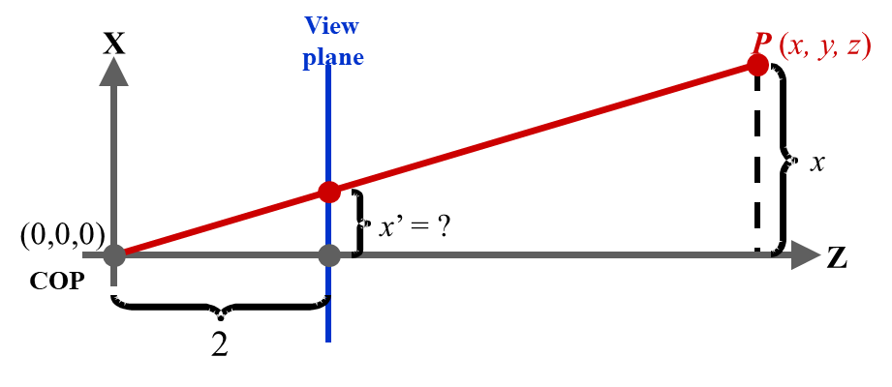
Figure 3.
Solution:
The relations between the point coordinates (x,y,z) and the projected coordinates (x’,y’,z’) are:
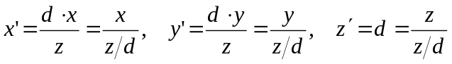 where d=2. (3 marks)
Use w to substitute z/d, 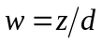, we have
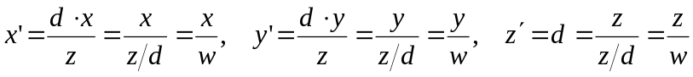 (1 mark)
Then using homogeneous coordinate system, the relations can be formulated as matrix form:
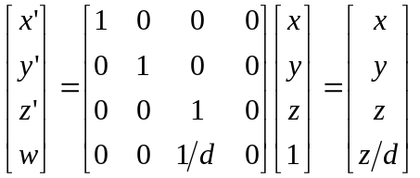 (1 mark)
The transformation matrix is: 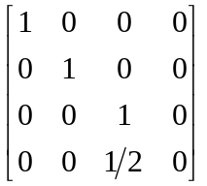 (1 mark)
( total 6 marks)

ii) In the world coordinate system, if the view plane normal is [4,3,0], the view-up vector is [0,0,1], the view reference point is [1,2,3], find the transformation matrix for parallel projection.
(10 marks)
Solution:
The translation matrix to the view reference point:
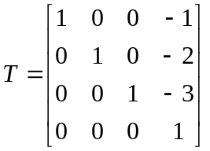 (1 mark)
The 3 axis vectors are (1 mark for n, 2 marks for u and 2 marks for v, up to 5 marks)
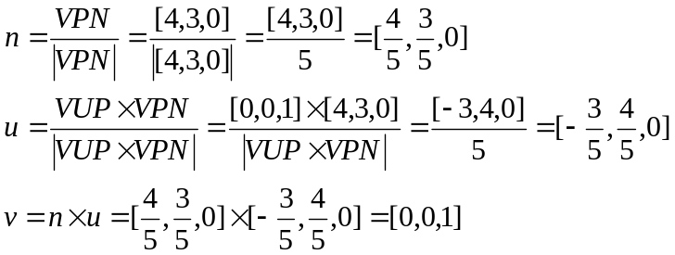
The rotation matrix is
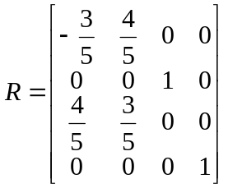 (2 marks)
The composite transformation matrix is
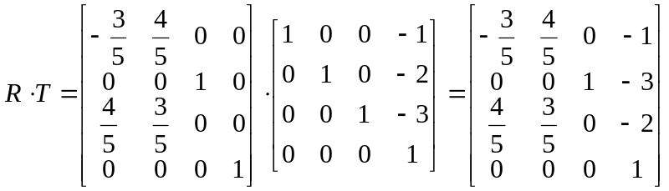 (2 marks)

(total 10 marks)

b) This question is about rasterisation. Use the line equation for a line from (x0, y0) to (x1, y1) to derive the mid-point algorithm for line generation.
[9 marks]
Solution:
Line equation: (x1 – x0)(y – y0) = (y1 – y0)(x – x0) or F(x,y) = 0 or
F(x,y) = (y1 – y0)(x – x0) – (x1 – x0)(y – y0) = (y1–y0)x–(x1–x0)y – (y1–y0)x0+(x1–x0)y0 (1 mark)
F(x+1, y) – F(x,y) = (y1–y0) (1 mark)
F(x+1, y+1) – F(x,y) = (y1–y0) – (x1–x0) (1 mark)
F(x+1, y+1/2) – F(x,y) = (y1–y0) – (x1–x0)/2 (1 mark)
We use 2F(x,y) = 0, dx=x1–x0, dy=y1–y0, (1 mark) then we have:
d(x0, y0) = 2dy – dx (1 mark)
d(x+1, y+1) = 2F(x+1, y+1) – 2F(x,y) = 2dy – 2dx (1 mark)
d(x+1, y) = 2F(x+1, y) – 2F(x,y) = 2dy (1 mark)
Move from (x0, y0) to (x1, y1) incrementally by x=x+1 (East) or x=x+1 and y=y+1 (North-East). (1 mark)
(total 9 marks)

